File Organization Techniques
Eniya B A – CSE A
230701085
Single-Level Directory Structure
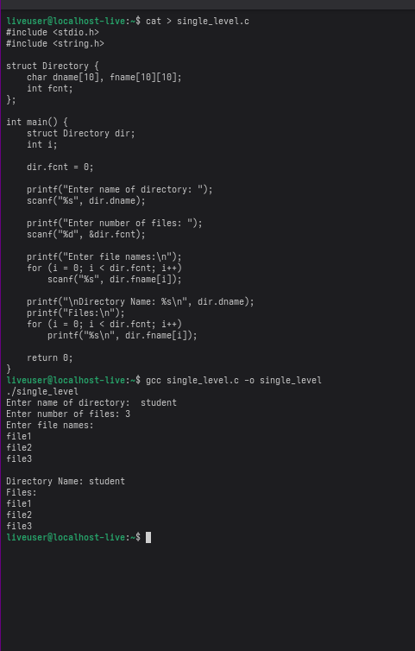

Two-Level Directory Structure
